OSB Automation: Menu Migration Utility
Purpose: it's intended for current osb site Menu data into new Template.

🚀 Project Setup & Run Guide (Python + VS Code)
This document explains how to set up and run the project step by step.
⚠️ Important: Always run the commands from your project’s root folder.

📌 1. Install Python
- Download from Python Official Download Page.
- Install with default settings, but make sure to ✅ check “Add Python to PATH”.
- Verify installation in a terminal:
- python --version

📌 2. Install Visual Studio Code
- Download from VS Code Official Website.
- Install with default settings.

📌 3. Open the Project in VS Code
- Open VS Code.
- Go to File → Open Folder… and select your project’s root folder (where view.py, requirements.txt, and input/ exist).
- Use the VS Code Integrated Terminal (press Ctrl + `) → this will automatically open the terminal in the project root folder.

📌 4. Install virtualenv
Run in the VS Code terminal:
pip install virtualenv

📌 5. Create Virtual Environment (root folder)
virtualenv venv
This will create a new venv/ folder inside your project.

📌 6. Allow Virtual Environment Activation
Windows PowerShell may block scripts. Run once in VS Code terminal:
Set-ExecutionPolicy -Scope CurrentUser -ExecutionPolicy RemoteSigned
Type Y and press Enter.

📌 7. Activate Virtual Environment
From VS Code terminal (root folder):
.\venv\Scripts\activate
✅ You’ll see (venv) at the start of your terminal prompt.

📌 8. Install Project Dependencies
Run:
pip install -r requirements.txt

📌 9. Running the Project
- Ensure (venv) is active.
- Place your updated sheet inside the input/ folder.
- Start the Flask application
python app.py
- Open your browser and visit:
http://127.0.0.1:5000
- Fill necessary details in settings section and save.

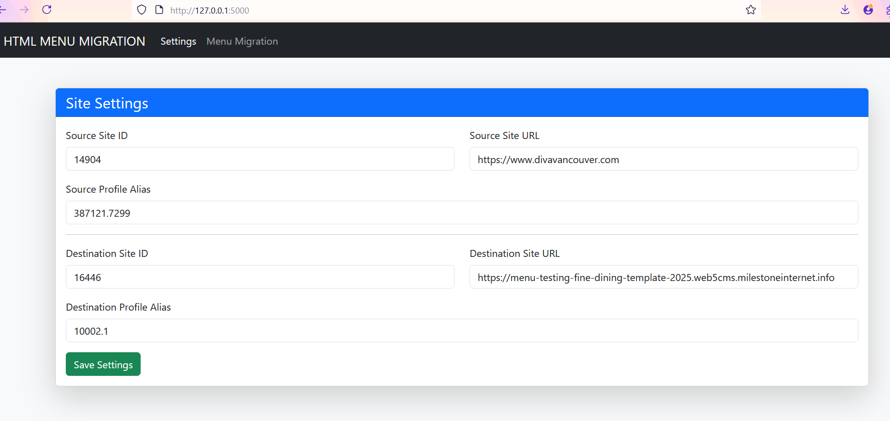

- Now go to menu migration section, verify and click on migrate menu.
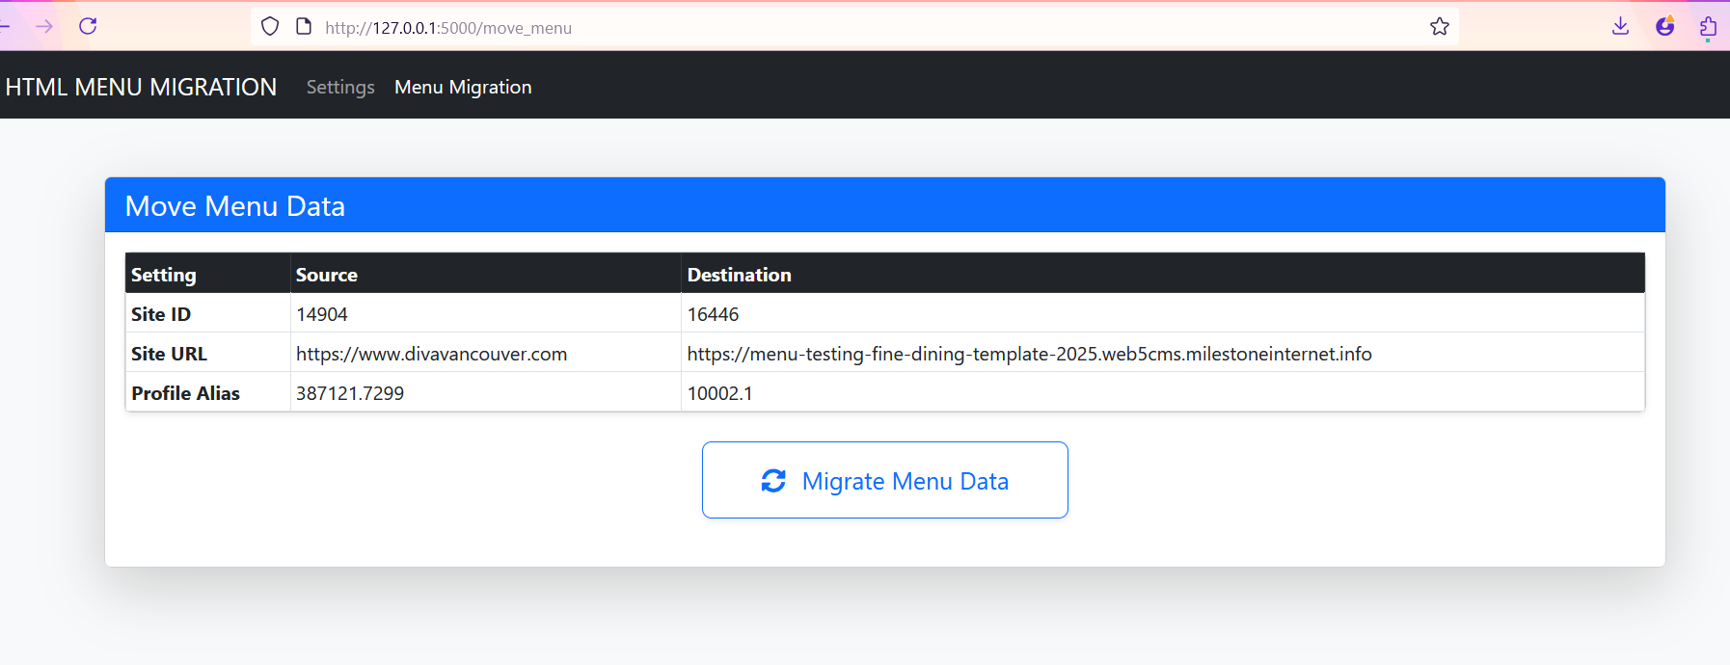

✅ Now your workflow is fully VS Code–based, always starting from the root folder.

🔁 From the Second Run Onwards
👉 You only need to follow
.\venv\Scripts\activate
python .\view.py

